Motif
What is wellbeing associated with? Don’t include yoga or anything like that. We’re talking about the therapy side of wellbeing.

Sparkles.

Hell YESSS!
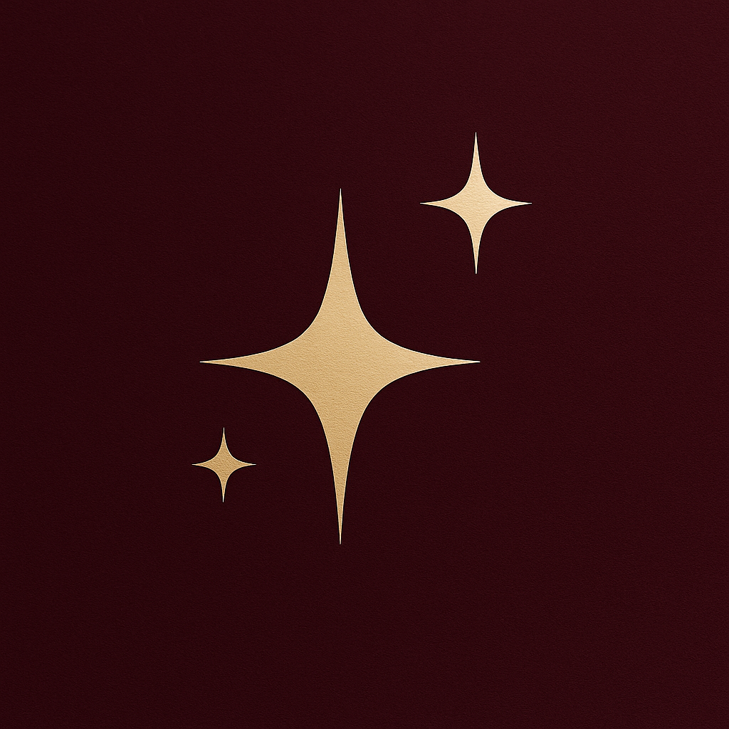

Let’s not copy this entirely as we need something original, but definitely keep to this. Also, stay away from the Subaru logo.

Colour Palette
// Add in the actual colours (2 of them) that you love. //

Hex Codes

#a0025d
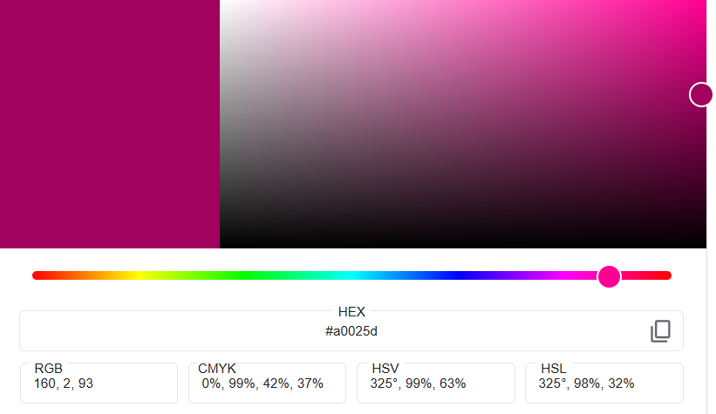

#9c055c
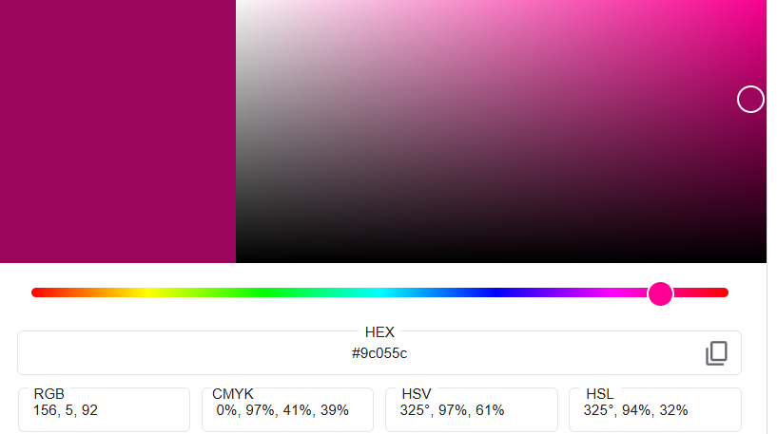

#551f53
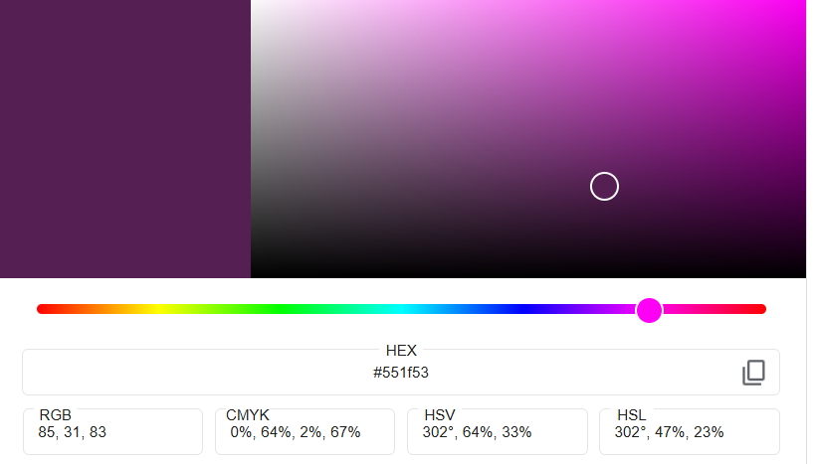
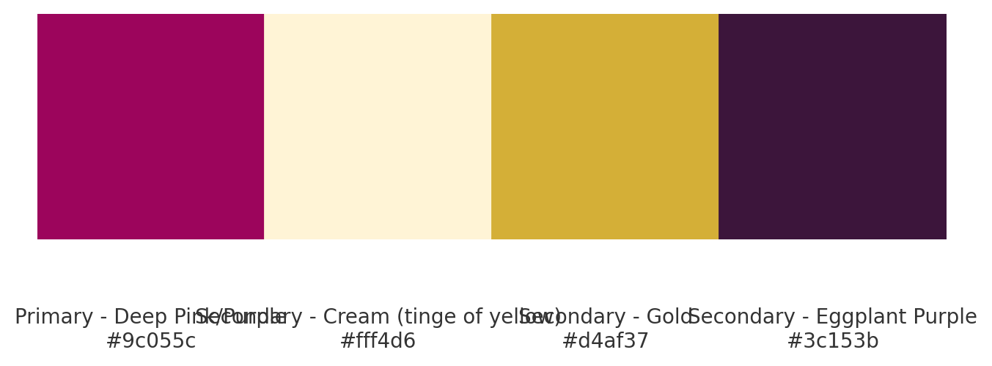

Primary – Deep Pink/Purple: #9c055c
Secondary – Cream (tinge of yellow): #fff4d6
Secondary – Gold: #d4af37
Secondary – Eggplant Purple: #3c153b

#400227 Suggestion instead of the other darker purple
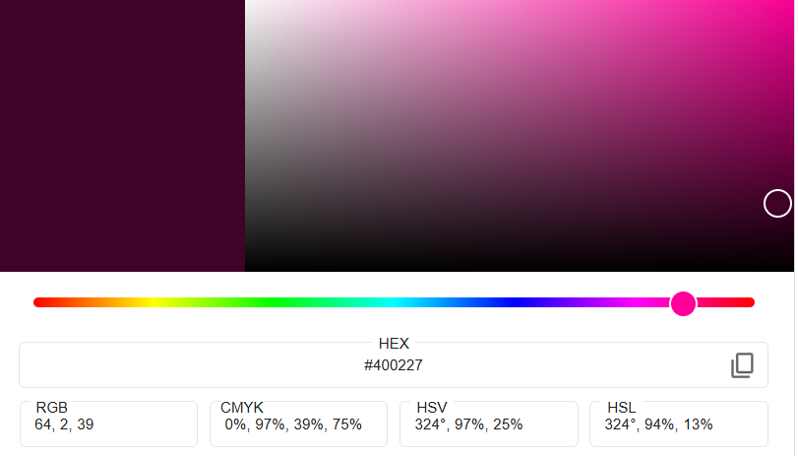

Fonts
Heading Fonts
Calluna (Calluna Semibold)
https://fonts.adobe.com/fonts/calluna

Secondary Font
FF Tisa Pro Light
https://fonts.adobe.com/fonts/ff-tisa

